UNIVERSITY DATABASE SYSTEM-RELATIONAL
SCHEMA MODEL
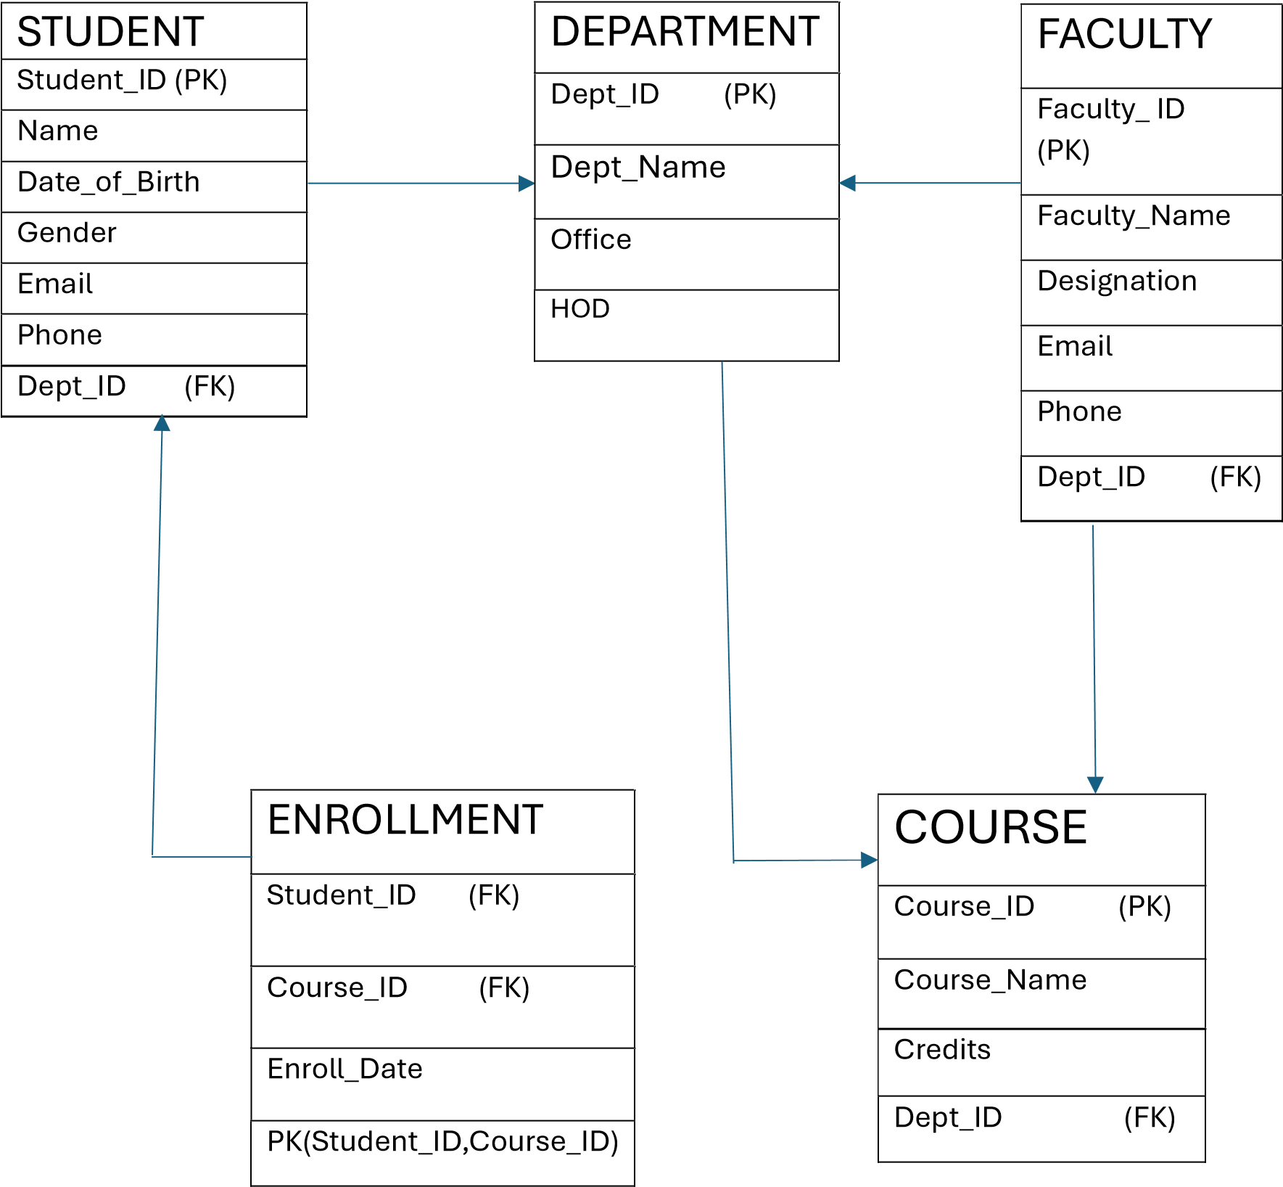

NAME : T.YAMINI  ROLL NO : 25B11AIB61
  PK – Primary Key
  FK – Foreign Key
  1 – One
  M - Many
  RELATIONSHIPS SUMMARY:
  Student belongs to department (M:1)
  Faculty works in department (M:1)
  Department o ers course (1:M)
  Faculty teaches course (1:M)
  Student enrolls in course (N:M)

